Exercise1：

3.

0: 0100 0000 0000 0101

1: 0001 0000 0000 0100

2: 0101 0000 0000 0101

4.

Binary Mnemonic Short Explanation

--------------------------------------------

1111 STP Stop the computer

0001 ADD Add accum. to operand

0010 SUB Subtract operand from accum.

0011 LOD Load memory cell into accum.

0100 LDI Load immediate into accum.

0101 STO Store accum. into memory cell

0110 INP Input value and store into accum.

0111 OUT Output the value from accum.

1000 JMP Jump to instructiona

1001 JNG Jump to instruction if accum<0

1010 JZR Jump to instruction if accum=0

5.

0: LDI 14

1: ADD 15

2: STO 10

6.

Five cycles

Exercise 5：

4.

I think it's 4

5.

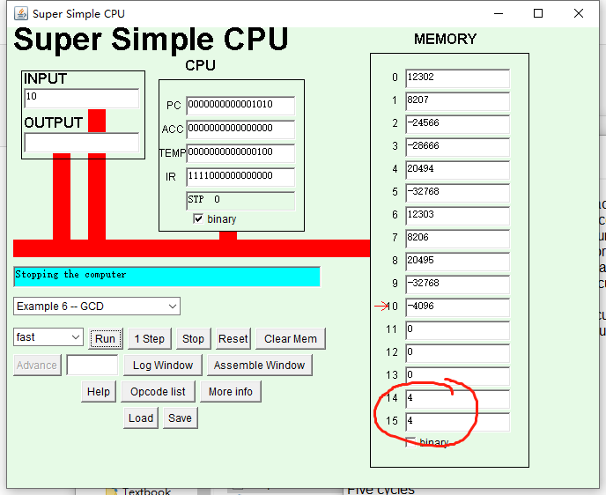

6.

I think it's 1, GCD for 30 and 31 seems to run forever. So I did it with 3 and 5

the app gives a 1

